Azure Functions is a serverless computing service from Microsoft Azure that lets you run small pieces of code in the cloud. You don’t have to manage servers or infrastructure — Azure takes care of that for you. Your code runs in response to events, like an HTTP request, a message in a queue, or a scheduled timer.
Key Features:
- Event-driven: Functions run when triggered by an event.
- Automatically scales based on demand.
- Supports multiple programming languages like C#, JavaScript, Python, Java, and more.
- Integrates smoothly with other Azure services such as Cosmos DB, Service Bus, and Blob Storage.

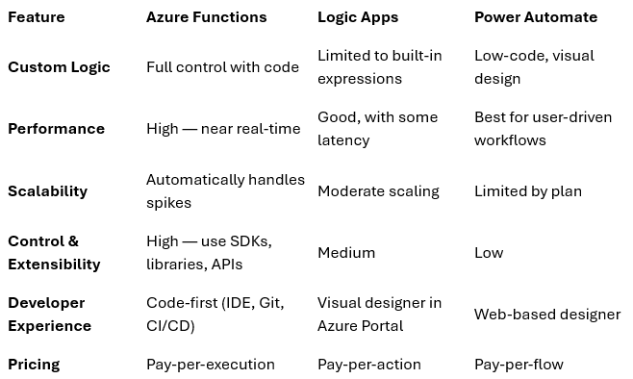

Real-Time scenario using Azure Functions
In an eCommerce platform, one of the key features customers expect is to quickly know whether a product is available in stock when they search for it. To deliver this experience efficiently, we can use an Azure Function as a lightweight, scalable, and cost-effective solution.
How It Works
When a user searches for an item on the website or mobile app:
- The front-end application sends a request with the product details (like SKU or product name) to a backend API.
- This request triggers an HTTP-triggered Azure Function.
- The Azure Function receives the request and: Calls multiple internal or external warehouse APIs or databases to check stock availability. Aggregates the responses to determine if the product is in stock, and how many units are available.
- It then sends a response back to the front-end system with the stock status and estimated delivery availability.
Why Azure Function is a Good Fit Here
- Event-Driven: The function only runs when a user performs a search, so you’re not paying for idle infrastructure.
- Fast and Stateless: Each stock check request is independent and quick, making a serverless function ideal since it can spin up, process the request, and shut down immediately.
- Scalable: If there’s a sales promotion or holiday rush with thousands of simultaneous searches, Azure Functions can automatically scale out to handle the load without any manual intervention.
- Cost-Effective: Since you only pay for the execution time, it’s much cheaper than maintaining dedicated servers for occasional stock check requests.
- Easy Integration: Azure Functions can easily connect with APIs, databases, or even Azure services like Azure SQL Database, Cosmos DB, or Azure API Management.

What Are Durable Functions?
Durable Functions is an extension of Azure Functions that allows you to build stateful, serverless workflows in code. This is useful for long-running processes, complex sequences, or workflows that need to track state between steps without requiring external storage or infrastructure.
Common Scenarios:
- Chaining actions: Running steps in sequence (e.g., Task A → Task B → Task C).
- Running parallel processes: Starting multiple tasks at once and combining the results.
- Delays or scheduled actions: Pausing workflows for a set time before continuing.
- Waiting for external events: Halting execution until a specific event or response occurs.

Real-Time use case
In a modern eCommerce platform, processing a customer’s order involves several steps that often depend on each other and sometimes require waiting for external systems to respond. Managing this process efficiently while ensuring reliability and scalability can be challenging.
This is where Durable Azure Functions come in — they help orchestrate long-running, multi-step workflows while maintaining state in a serverless environment.
How It Works
When a customer places an order, The front-end application sends an order request to the backend. This triggers a Durable Orchestration Function. The orchestration function then coordinates multiple steps in sequence:
- Validate the order details.
- Check stock availability by calling other Azure Functions or APIs.
- Wait for payment confirmation from an external banking service, which might take several minutes.
- Arrange shipping by calling a third-party logistics API.
- Send an order confirmation email to the customer.
Throughout this process, the Durable Function maintains the state and tracks progress between steps.

Why Durable Azure Function is a Good Fit Here
Orchestrates Multiple Dependent Steps: The order processing workflow involves several tasks that need to happen in a specific order. Durable Functions can manage this easily without complex external systems.
Handles Waiting Periods: Payment confirmations or external API calls can take time. Durable Functions can wait asynchronously without holding up compute resources, resuming once the task is complete.
Stateful in a Stateless World: It keeps track of the workflow’s state and progress between tasks, without the need for a database or external state management.
Resilient and Reliable: Automatically retries failed tasks and can resume workflows from where they left off if something goes wrong.
Scalable and Cost-Efficient: Like regular Azure Functions, you only pay for the compute time you use, and it can scale automatically to handle multiple order workflows in parallel.
Example Flow
A Customer places an order for "Wireless Earbuds"
1. Durable Orchestration Function triggered
2. Calls Activity Function to validate order
3. Calls Azure Function to check stock
4. Waits for payment confirmation from external bank API
5. Calls API to arrange shipment
6. Sends order confirmation email
7. Workflow completes successfully
If any step fails (like payment timeout or stock unavailability), the Durable Function can handle retries or gracefully fail the workflow and notify the customer.

